|  |  |  |
| --- | --- | --- |
| **Title:** | | MiVoice Business Console 8.0 - Master profile |
| **Abstract:** | | This document describes the configuration and behavior associated with the MiVBC master profile creation and import. |
| **Corporate Reference:** | |  |
| **Document Number:** | | **DKxxx** |
| **Originator:** | | Pankaj Dubey |
| **Department:** | | MiVoice Business Console |
| **Location Of Issue:** | | Kanata, Ontario, Canada |
| **Date Originated** | | 4/30/2015 9:19:54 AM |
| **Total Pages:** | | 17 |
| **Change Level:** | | 1 |
| **Change Date:** | |  |
| **Security Level:** | | Sensitive |
| **Supersession Data:** | |  |
| **Issue Date:** | Information Control: | |
|  |  | |

Table of Contents

1. Introduction 2

1.1 Purpose 2

1.2 Scope 2

1.3 Change Control 2

1.4 References 2

1.5 Acknowledgments 2

1.6 Glossary of Terms 2

2. Requirement 3

3. SYSTEM Overview 4

3.1 System Boundaries 4

3.2 System Behaviors 4

3.3 Master Profile Configuration 5

3.3.1 Fresh install 5

3.3.2 Upgrade install 7

3.4 Import of master profile 10

3.5 Verifications at Console startup 12

4. System Behaviors 13

4.1 Backward compatibility 13

Appendix A: Review Minutes/Comments and Actions. 14

5. Approvals 15

# Introduction

## Purpose

This document will describe the configuration and behavior associated with the MiVBC ability to create and re-use the master profile (i.e. common configurations) for all consoles working in a particular network or company.

## Scope

This document applies only to the MiVoice Business Console (MiVBC). 5550 IP Console is not supported.

## Change Control

| **Change**  **Level** | **Date** | **Comments** |
| --- | --- | --- |
| IP01 | December 10, 2015 | Initial Draft |
| IP02 | December 11, 2015 | Internal review comment incorporated |
|  |  |  |

## References

## Acknowledgments

## Glossary of Terms

* **MiVBC** – MiVoice Business Console
* **Shared location** - \\10.112.xx.xxx/some_folder_name
* **Master consoles** – Consoles whose ‘Administrative Access’ checkbox is checked at configuration wizard.
* **Non-Master consoles** – Consoles whose ‘Administrative Access’ checkbox is not checked at configuration wizard.

# Requirement

After installation, MiVBC initial settings (*like* *ADF, BLF, BB etc. paths*) are repetitive for an administrator when required to set-up multiple number of consoles (i.e. 15-20 consoles). For making it easier these common configurations done for first console will be kept at a **shared location on network**, which can be imported by remaining consoles on their PCs. So the issue of providing same paths/settings again and again on multiple PCs will be resolved.

# SYSTEM Overview

## System Boundaries

System boundaries include the MiVoice Business Console Software, and an accessible shared location (a folder) on network which is used to read and write master profile XML file for importing/exporting configurations between master and non-master consoles.

## System Behaviors

This feature has following four categories or behavior:

1. Master Profile Configuration.
2. Import of master profile.
3. Verifications at Console startup.
4. Backward compatibility.

## Master Profile Configuration

### *Fresh install*

1. **Configure Console to generate master profile**

The master console(s) need to check below checkbox and mention the path where master profile will be generated. Non-masters need to fill in the path if they supposed to use the master profile, none of these two options (a checkboxes and a textbox) are forced to be checked or filled as operator may want a default console without master profile feature.

***Explanation:***

* If ‘Use Master Profile’ is checked and ‘Master profile file folder path’ is non-blank then this console will act like a master console and can read and write master profile.
* If ‘Use Master Profile’ is checked and ‘Master profile file folder path’ is blank then this console will write master profile but will not be reading it on start.
* If ‘Use Master Profile’ is not-checked and ‘Master profile file folder path’ is non-blank then this console will act like non-master console i.e. will only be importing configured master profile values on every start/re-start.
* If both of these checkbox and textbox is uncheck and blank respectively, it means that this console will not be using master profile feature.

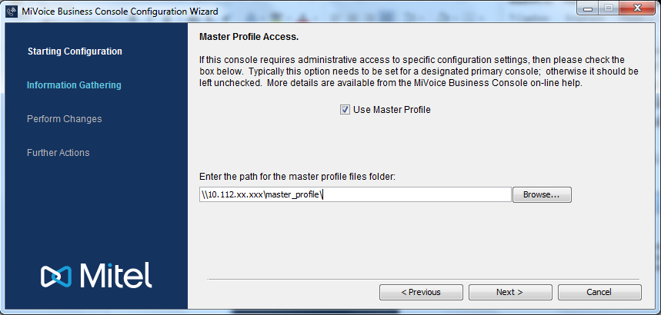

*Key points:-*

* ***For Master console*** –
  1. “Use Master Profile” checkbox need to be necessarily checked and location path to filled for creating master profile.
* ***For Non-Master console*** –
  1. Only “master profile files folder” path need to be supplied, if they want to use this feature else simply click “Next” and proceed.

1. **Open Console and generate master profile**

* Start the Console.
* Go to **Tools->Options** “Master profile panel”, select the fields (or options) to be stored in the master profile.
* Press apply or ok to save the settings to the folder selected during configuration wizard (in step-1 above).

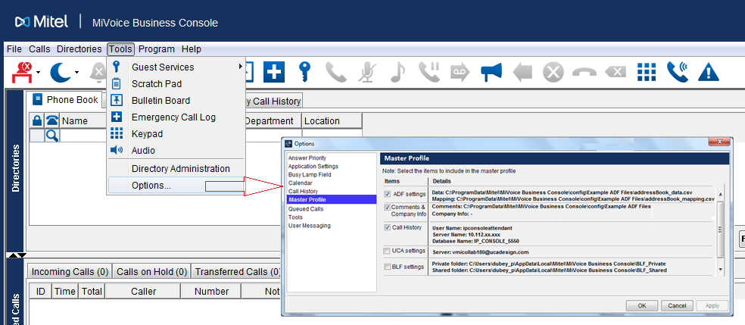

*Error popup messages (at “OK/Apply”), if any:*

Master profile export failed because of following reason(s):-

* 1. 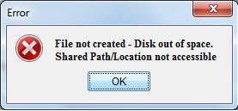
  2. A system error occurred. Please contact administrator.

*Key points:*

* Call History – Passwords will be kept encrypted, however database server IP addresses will be kept as it is as they are common to all operators.
* In case of UCA, calendar etc. only server IP’s will be exported, user credentials needs to be provided by operator themselves.
* Master profile XML includes the windows user name of master console and last updated date/time, this way we’ll comes to know which master console has updated it. However we are not keeping any file backups.

### *Upgrade install*

In case of application upgraded the configuration wizard will not appear again, so by making use of values saved using earlier version of console for master profile will start functioning, until/unless the master console makes some changes into it and ask other consoles to change their master profile folder paths pointing to new master profile XML file.

List of configurable items with details to be displayed in Master profile panel for selection: -

|  |  |  |  |
| --- | --- | --- | --- |
| **Section** | **Item** | **Values** | **Can be part of Master Profile** |
|  | Multiple Company Directory | On/off | Yes |
| Clear Phonebook on Answer | On/off | Yes |
| BLF List Select on Answer | On/off | Yes |
| Phonebook Lookup on Answer | On/off | Yes |
| Phonebook Search all from Name Field | On/off | Yes |
| Transfer Assistant on Answer | On/off | Yes |
| Transfer Mode | Dial/  Dial and Release/  Dial, Release & Answer | Yes |
| Directory Administration | Use Additional Database Fields Feature | On/off | Yes |
| Multilingual Name Display | On/off | Yes |
| Directory Data File | Path + Filename | Yes |
| Directory Mapping File | Path + Filename | Yes |
| Comments File Configuration | Path | Yes |
| Multiple Company Directory file | Path + Filename | Yes |
| Phone Book max entries | 10-999 | Yes |
| Load ADF Directory Data Schedule | On/off | Yes |
| Load ADF Directory Data Minutes | 1-99 minutes | Yes |
| ESM Telephone Directory Export file | Path + Filename | No – should only be done on the admin console |
| ESM Phonebook Directory Export file | Path + Filename |
| ESM Telephone Directory Synchronization - schedule | On/off |
| ESM Telephone Directory Synchronization  – daily time | hh:mm |
| Options – Answer Priority | Answer basis | First-come, first-served/  Assigned line priorities | Yes |
| Line Priority - F1 | 1-7 |  |
| Line Priority - F2 | 1-7 |
| Line Priority - F3 | 1-7 |
| Line Priority - F4 | 1-7 |
| Line Priority - F5 | 1-7 |
| Line Priority - F6 | 1-7 |
| Line Priority - F7 | 1-7 |
| Application Settings | Screen Pop | Yes/no | Yes |
| Language | 12 supported languages | Yes |
| Auto Unmute | On/off | Yes |
| Busy Lamp Field | Enable Busy Lamp Field | On/off | Yes |
| Private BLF List folder | Path | No |
| Shared BLF List folder | Path | Yes |
| BLF Tile View columns | 1-99 | Yes |
| Calendar | Enable Calendar | On/off | Yes |
| Email Address |  | No – unique per operator |
| Email Password |  |
| Exchange Server Address |  | Yes |
| Call History | Enable Call History | On/off | Yes |
| Password |  | Yes – common to operators, will be encrypted |
| Database Server Name |  | Yes – common to operators |
| Queued Calls | Incoming Calls Threshold | 1-25 | Yes |
| Incoming Calls Timeout seconds | 0-999 | Yes |
| Transferred Calls Timeout seconds | 0-999 | Yes |
| Parked Calls Timeout seconds | 0-999 | Yes |
| Tools | Guest Services Enabled | On/off | Yes |
| Max entries from Guest Services search | 10-999 | Yes |
| Bulletin Board file | Path + File name | Yes |
| User Messaging | Enable Presence Integration | On/off | Yes |
| User Login ID |  | Yes – this could be common to multiple operators if the same DN is being used by multiple users on the same PC. Password will be encrypted. |
| User Password |  |
| Server |  |
| Chat away status timer | 2, 5, 10, 15, 20 min, 1hr | Yes |
| Predefined Messages folder | Path | Yes |
| Problem Reporting |  |  | Yes |
| Audio Panel | Headset/handset |  | Yes |
| Volume |  | Yes |
| Headset/handset |  | Yes |
| Volume |  | Yes |
| Ringer |  | Yes |
| Volume |  | Yes |
| Hear ringing on handset/headset | On/off | Yes |
| Incoming call (idle) | None/Ring/Tone | Yes |
| Incoming call (busy) | None/Ring/Tone | Yes |
| Window specific information | Size |  | No |
|
| Buttons |  | No |
| Columns |  | No |
| Source/Dest area |  | No |

## Import of master profile

All consoles (*master/non-master both*) will automatically get master profile from the path provided in textbox on every console start-up, if they are using an older version of master profile i.e. last imported ‘Date/time’ of master profile will be compared with file available at shared location.

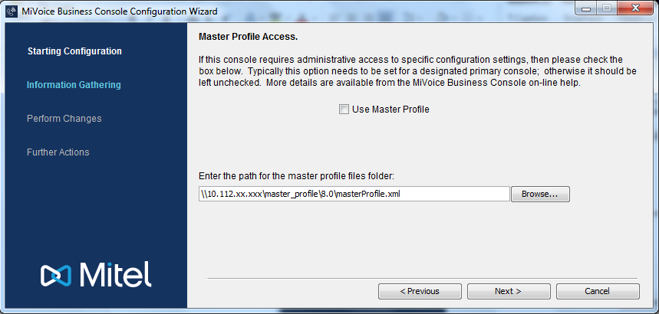

Figure 2.4: Master profile import screen (Configuration wizard)

*Note:* -

* If non-master console don’t want to use *master profile feature* then they need not to provide any path here and simply click “Next” and proceed.
* Non-masters consoles will only provide path till master profile XML and leave the ‘Use Master Profile’ checkbox un-checked.

***Error tooltip messages (at console startup – refer next Section 2.6):***

***Case 1***

Master profile failed to import. The console is started with previous settings:-

* Master profile file not found.
* Master profile format error.
* Master profile has been created with a newer software release.
* Master profile has been created with an older software release.
* XML format not supported/corrupted.
* Version mismatch – Please upgrade your console version to x.x for importing this master profile.
* A system error occurred. (logged in logs with message to user)

**Action:** Contact system administrator for assistance.

***Case 2***

Master profile failed to import. The console is started with previous settings:-

* Master profile location not accessible - This problem may be intermittent network issue

**Action:** Restart console after sometime when network is available.

## Verfications at Console startup

As the master profile is imported on every console start-up, following indicators will be displayed at “status area” to make operator aware about it.

**Indicator 1: Master profile import failure – RED icon**

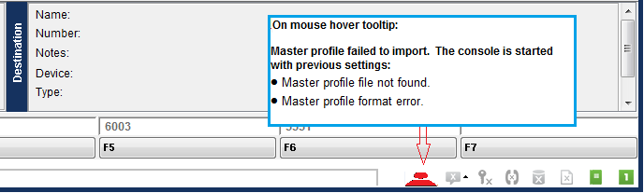

In case of failure - ‘red’ icon displayed, previous setting will be retained. On mouse hover tooltip shows reasons of failure.

**Indicator 2: Default settings changed, will overwrite on next startup – ORANGE icon**

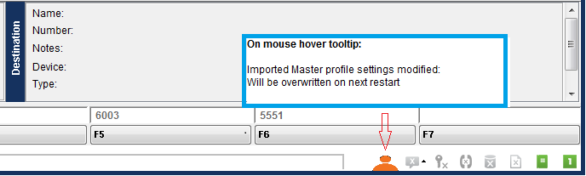

‘Orange’ icon indicates that original configurations which was imported on startup has been changed by operator i.e. these setting are not present in the master profile at shared location. This means it will be overwritten on the next console restart.

**Explanation:**

Operators are free to modify default values set by an automatically master profile import. As they may need to change some paths, server IP’s etc. But if they do, there will be an ‘orange’ indicator icon at ‘status area’ and on its tooltip, a message saying that these changes will be overwritten on next console re-start. So, if they really want to keep their settings, they need to remove the path of master profile file from configuration wizard (***refer Figure 2.4***).

**Note: -** No icons if all setting imported successfully and none of them has been modified later.

# System Behaviors

## Backward compatibility

The master profile will be created within a directory of current consoles version (i.e. 8.0, 9.0 etc.) inside shared location on a network. So at time of console upgrades they still able to fetch master profile settings from previously configured paths until they re-generates it using latest version of console.

**Explanation:-**

The directory structure of master profile XML file will be:-

1. Initial master profile generation

\\10.112.xx.xxx/master_profile_folder/**8.0**/Master_Profile_Operator-1_13:20.xml

1. In case of upgrades

\\10.112.xx.xxx/master_profile_folder/**9.0**/Master_Profile_Operator-1_15:00.xml

1. Review Minutes/Comments and Actions.

# Approvals

1. Approval indicates acceptance of the document contents as a whole and its suitability for release and use at the change level indicated (signatures must be in black ink).

|  |  |  |  |  |
| --- | --- | --- | --- | --- |
| APPROVED BY |  |  | SIGNATURE |  |
| POSITION |  |  | DATE SIGNED |  |
| DEPARTMENT |  |  |  |  |

|  |  |  |  |  |
| --- | --- | --- | --- | --- |
| APPROVED BY |  |  | SIGNATURE |  |
| POSITION |  |  | DATE SIGNED |  |
| DEPARTMENT |  |  |  |  |

|  |  |  |  |  |
| --- | --- | --- | --- | --- |
| APPROVED BY |  |  | SIGNATURE |  |
| POSITION |  |  | DATE SIGNED |  |
| DEPARTMENT |  |  |  |  |